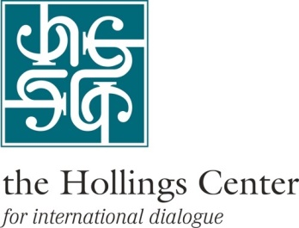

**Dialogue Snapshot**

**Protecting Cultural Heritage in Conflict:**

**A Dialogue on Emergency Efforts**

**October 2015**

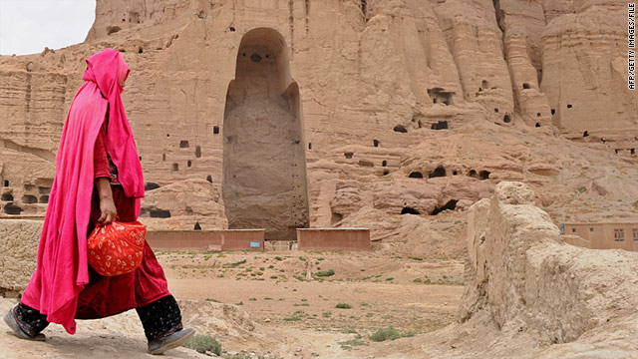For any observer of Taliban reign in Afghanistan, the images of the collapsing Bamiyan Buddhas in 2001 must be emblematic of the high price of war and extremism on humankind’s common cultural past. Likewise, for the current generation that is witnessing one of the worst humanitarian disasters in history, the explosion of Palmyra is an unforgettable image that will always remind us of the thousands of other atrocities committed during the Syrian war. The destruction brought by years of armed conflict on the cultural heritage of Iraq and Syria is almost unfathomable. The emergence of Da’esh, the term for the Islamic State in Iraq and Syria currently used by the U.S. Secretary of State, has exacerbated the threat to cultural heritage in a region considered to be the cradle of civilization, thus international cooperation on its protection remains paramount.

To this end, the Hollings Center for International Dialogue collaborated with the Penn Cultural Heritage Center at the University of Pennsylvania and the Smithsonian Institution to organize a dialogue entitled ***Protecting Cultural Heritage in Conflict: A Dialogue on Emergency Efforts*** in Istanbul from 14-17 October, 2015. The objective of the dialogue was to bridge the gap between laws, statements and action with actionable policy recommendations. The organizers also aimed to create a network of practitioners (preservationists, archeologists, and anthropologists), policymakers, and representatives from international civil society organizations that work in cultural heritage preservation. Key points worth highlighting from the dialogue were:

* Much of the international media attention has been on tangible cultural heritage such as monuments, historic sites, and antiquities. While this has been instrumental in raising awareness, there are a host of intangible cultural elements that are under threat due to war and displacement.
* Emergency preparedness and disaster response are essential and need to be put into action plans and budgets at times of normalcy and peace.
* Cultural institutions such as museums need institutional reform to ensure better knowledge transfer across generations as well as amongst themselves.
* Technology is a double-edged sword: while it is helpful in knowing and advocating about what is going on with regards to cultural heritage, it might be giving extremists the platform they need to prove their destructive capability to the world. Some technologies are still extremely expensive and thus harder to employ in a war and poverty-stricken region.

**Cultural Heritage is Multi-Dimensional**

***“For us, cultural heritage is what we are attached to, what we deal with in daily life, the environment in which we grew up. It is what is listed and not listed to be protected. Starting from one’s own family heritage to national heritage, it is all the layers in between.” – Syrian participant***

UNESCO describes cultural heritage as things of “outstanding universal value from the point of view of history, art or science.” However, cultural heritage destruction means more than the destruction of physical sites and artifacts. Participants underlined that destruction of cultural heritage is occurring at a scale way beyond the imagery covered in the media. Cultural heritage destruction is an element of any military strategy, and is not exclusive to extremists or terrorists. Some participants mentioned the damage done to Iraqi cultural heritage by years of U.S. occupation. According to one participant, “Removal, displacement and destruction of cultural heritage is a tool to destroy communities.”

While the term cultural heritage first brings to mind monuments, architecture, heritage sites, and artifacts, a broader conception of cultural heritage is needed and is unfortunately lacking in the current responses. Traditions, songs, words, language, food, dance, etc. are all part of intangible cultural heritage. A participant said that values such as dialogue, hospitality, diversity, tolerance and inclusion are also elements of cultural heritage. These values are key in the formation of individual and group identity, which means additional layers of loss when cultural heritage is destroyed. A participant noted, “It is not just buildings, not just stones, not just art – it is our identity”.

Relatedly, cultural heritage destruction has not only “gutted the landscape” but also affected displaced communities by cutting off further their links to their geographical and cultural past. Cultural experts are grappling with an important question brought about by mass immigration: are we facing a new era of Iraqi and Syrian diaspora in the West? And if so, how can one retain cultural practices and values in these immigrant communities without hindering effective integration into host countries? Participants who were living outside their own country (either by choice or necessity) commented that it is inevitable that new subcultures develop within the diaspora that blend elements of culture from origin and host countries. This is only natural since culture itself is ever-changing. Yet it is important to keep in mind that intangible cultural heritage is fragile.

A good case in point for this fragility is the situation in refugee camps. According to a participant who has worked in these camps, people there are in a state of limbo, leaving one life behind but unable to start a new one. The other bitter reality is that for children and young adults, there is little memory of historic sites, monuments or festivities. “If I ask a child, Syria is just the tent he lives in” said one participant. The generation that is supposed to carry the knowledge of Syria’s cultural heritage has become refugees and immigrants. This has motivated UNESCO to do more cultural work in refugee camps such as celebrating national holidays, replicating festivities, documenting children’s games, songs, and other intangible cultural traditions.

While these are common problems posed by war and displacement of people, some participants raised the issue that even under more stable conditions, cultural heritage education has not been given the importance it deserves in this region that is the cradle of civilization. Iraq and Syria are not the only examples; there are other countries where the curricula on cultural heritage have been selective to reflect the cultural legacies of certain ethnic or religious groups. An Iraqi participant stated that the ethnic, linguistic, and religious diversity in Iraq should be the cultural richness passed on to future generations, but it is exactly this diversity that is dying. Under these circumstances, there is a great role to play for those concerned with preserving both tangible and intangible cultural heritage. If formal education has not been able to do it, it is up to practitioners to engage communities and raise awareness about the value of their own cultural heritage. While many such efforts have been undertaken by international actors, a major critique directed at those working in the Middle East is that practitioners on the ground do not pay attention to the optics of their presence, and may thus be seen as outside imposers coming in to educate the ignorant public. Efforts to raise awareness of cultural heritage must be seen as a largely local effort.

In a troubled region where political, ethnic and religious conflicts have prevailed and dominated people’s lives, cultural heritage awareness should not be taken for granted. A participant’s example was her own village where archaeological excavations were perceived as treasure-hunting. When communities are not effectively engaged as partners with an ownership stake in their own cultural resources, they are unlikely to steward them wisely. Ongoing conflict and lax governance turn cultural heritage into lucrative business for looters who traffic stolen artifacts across borders and through illegal markets.

**Managing Cultural Heritage**

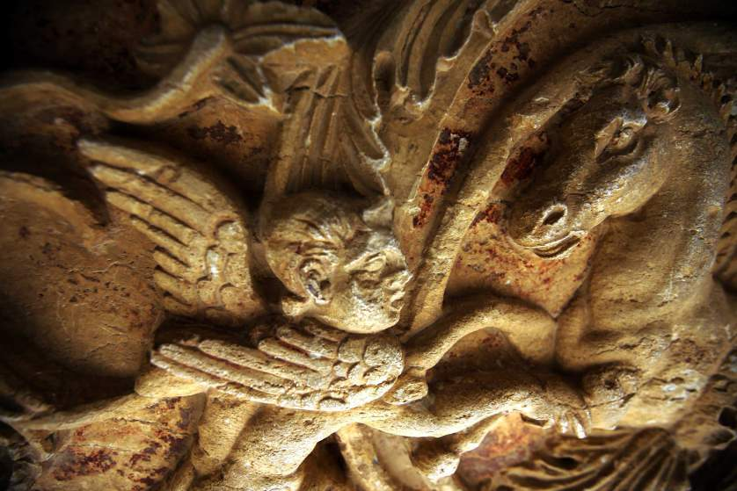Khaled al-Asaad, a Syrian archaeologist and the head of antiquities for the ancient city of Palmyra, was murdered in August 2015 while trying to safeguard the hidden artifacts excavated from the UNESCO world heritage site. This incident is only one example of the hardships and danger facing cultural heritage workers on the ground, especially in Da’esh-controlled areas. One of the objectives of this dialogue was to address such hardships and create and enhance support networks among cultural heritage professionals. Cultural heritage work in conflict zones is currently undermined by ineffectual organization systems, undertrained workers, and limited access to an international network of cultural care professionals. Against this backdrop, participants mentioned efforts to leverage networks into improved emergency preparedness, take advantage of opportunities for training at home and abroad, and seek increased on-the-ground support from UNESCO and other international agencies and organizations.

Perhaps the main issue cultural heritage workers face is that in the face of a massive humanitarian disaster, urgent human needs take priority over cultural heritage protection. This is understandable, yet poses a challenge to preservationists and the international community. All resources are scarce under war conditions, yet practitioners are expected to continue tending to the country’s heritage and persuade the world of the importance and urgency of cultural heritage preservation with essentially no support. These times call for influential spokespeople to come forth and draw attention to these issues so that more resources are channeled into this effort, as doing so will be important to any post-conflict reconstruction. The failure to do so cannot be ignored, as the long term impact of cultural heritage destruction is almost as severe as the immediate loss of life. A participant quoted a former Turkish President: “Destroying cultural heritage is like killing a human being. When Mostar Bridge (in Bosnia Herzegovina) was bombed, witnesses were screaming as if they were seeing a person being murdered.”

Precautions, procedures and protocol are critically important in cultural heritage management. These need to be put in place at times of peace to be used in times of conflict or emergency. These are not only designed to protect the heritage at risk, but also make sure that the people tasked with this difficult job have the necessary human networks in place when crisis hits. The formation of these networks at local, national and international levels requires time and material investment. Local network formation necessitates building a culture of cooperation with and among the public, security forces, first responders, and other relevant groups. This may not be as easy as it sounds since it raises deeper questions about civilian-military relationships in the countries in question. How can you interact with a military that has historically been oppressive or lacked regard for cultural heritage in the first place, let alone make them partners in conflict response? Participants had some disagreements on this issue. While some talked about best practices of involving local law-enforcement and military personnel in disaster response and emergency preparedness (most notably in Sulaimaniyah, Iraq and Minnesota, US), others were skeptical about bringing the military into what they felt needs to stay a civilian space.

Another challenge is that both in Iraq and Syria, there is a culture of top-down decision-making, which contradicts with the spirit of formulating horizontal networks. Participants who have successfully built and implemented emergency preparedness plans emphasized that challenges will differ from one region and context to the other, but in order to respond in an effective and efficient manner to a disaster, these challenges will need to be overcome.

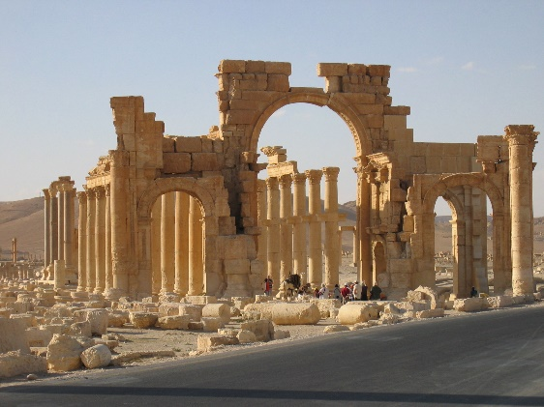Some other problems preservationists face in their daily work, independently from the dire conditions of war, conflict and displacement are: inconsistent documentation and record-keeping, institutional knowledge gaps, insufficient training for workers, insecure data and disappearing documents, and a top-down approach to personnel management. Participants discussed possible solutions and came up with the following action items: running training programs to bring knowledge and skill levels of local cultural heritage workers to an international standard; capacity-building; training on emergency/crisis response plans. Institutions such as the Metropolitan Museum or the Smithsonian Institution offer courses in curatorial methods, conservation, and emergency preparedness; however participants stated that getting visas for visiting scholars and preservationists has been difficult. This is an area where Europe and the US can do more to be of help, but it will become more difficult as spillover from the Syrian civil war results in tightened visa regimes around the world. Others suggested that a remedy to this can be increasing the number of local centers of excellence such as the Iraqi Institute for the Conservation of Antiquities and Heritage and UNESCO’s Arab Regional Center for World Heritage.

**Institutional Memory**

The issue of institutional memory retention was discussed in depth and participants came up with some suggestions on how information can be better transferred within institutions. A common problem that not only exists in war-stricken regions but also in Europe and the US is a deficient culture of archiving. Archives can serve as a repository not just of artifacts, but also institutional memory. A seasoned Iraqi archaeologist testified that even in the world-renowned Louvre, there is no central archive. But an Iraqi expert noted that of the alleged four million documents in the Iraq National Museum, some were lost, damaged or deliberately destroyed. These items are all “perishable” – they are fragile paper and scanning them poses its own problems and risks. Digitization can be more costly than it seems, as it is technology-intensive and requires certain bandwidth and internet speed. Such options are not always available, particularly in periods of conflict.

The Iraqi archaeologist also pointed at a deficit of communication between generations. In this person’s opinion, whereas elder preservationists would like their junior colleagues to show eagerness, curiosity and respect for their institutional knowledge, younger cultural heritage professionals have an individualistic attitude and do not actively share knowledge regarding technology, best practices, etc. that they have received through international training.

Hurdles to institutional memory transfer are somewhat different in Iraq and Syria. In Iraq, the country’s political turmoil interrupted the continuity of institutions. The 2003 American invasion resulted in many educators and archaeologists losing their jobs, excluding their experience from the reconstruction phase. There are very few cultural heritage experts who are alive who can tell the history of cultural heritage from the 1940s. In Syria, institutional memory disruption has occurred as a result of the ongoing civil war and subsequent displacement. Neither expertise nor institutional knowledge is not in the same place as the cultural heritage. So how do you connect the community of preservationists who are now internally or externally displaced (as was the case with many dialogue participants) to the heritage they should be studying?

Both for Iraq and Syria, the issue of institutional memory retention and knowledge transfer (whether across generations or geographical locations) can happen through oral history projects. Participants seemed eager to conduct such interviews for archiving purposes as well as for practical use. It was also a shared hope and objective to work towards an international standard of curatorial methods, database management and archiving, especially now that preservation of heritage is so sensitive. To get to those international standards, participants suggested a few practical steps:

* Use process mapping to streamline the steps of cultural heritage management. A pilot program for this could be getting together cultural heritage professionals to create procedures manuals for those working outside of the mainstream with limited access to international resources. While some raised the issue of translation and costs, others gave suggested crowdsourcing.
* Establishment of a non-political clearinghouse to share resources such as articles, portfolios, dissertations, oral histories and interviews. Realistically this would require non-governmental efforts and possibly international funding.

**The Use of Technology**

Thanks to technological advances, there are a host of high-tech tools available to cultural heritage preservationists. However the question in the dialogue centered around how to widen the access to those high- tech methods as well as what low-tech or no-tech methods that are less costly are at the service of cultural heritage preservation. When it comes to cooperation with the international community on transfer and use of technologies, questions of management, ownership and dissemination also arise. Lack of access, lack of training, and data security are the roadblocks to effective local use of existing and emerging technology in Iraq and Syria.

The unprecedented destruction by human hand of numerous historic sites, artifacts and buildings has necessitated a faster and more efficient documentation of those that have survived. For local populations who are making an effort to show cultural heritage damage to the world, use of geographical information such as GPS coordinates are crucial, because that is the only way their images can have the necessary metadata to hold culprits accountable. A participant who has aided rights groups in documenting human rights abuses in different contexts emphasized that GIS and GPS coordinates (see glossary) were instrumental in presenting conclusive evidence to courts. These are examples of low-cost technologies that people take for granted, but are essential to preservation efforts and prosecution of atrocities.

Another widely used form of documentation is photogrammetry. Accurate 3-dimensional recapitulations of sites, buildings and artifacts are unfortunately the only way certain cultural heritage will be able to live on even after their destruction. A participant noted that while photogrammetry software can be expensive, there are efforts to develop more openly accessible programs and applications that will facilitate the production of photogrammetric visuals. The participant also suggested that technology innovators are increasingly more interested in humanitarian efforts than putting their skills at the service of the military or the private sector.

**Mini-Glossary**

**Drone:** An unmanned aerial vehicle that has civilian uses such as aerial photography, in addition to its more widely known military use.

**DSLR:** A digital camera combining the optics and the mechanisms of a single-lens reflex camera with a digital imaging sensor, as opposed to photographic film.

**Geo-tagging:** The process of adding geographical identification metadata to various media such as photographs, videos, websites, SMS messages, etc.

**GIS:** Geographic Information System is a system designed to capture, store, manipulate, analyze, manage, and present all types of spatial or geographical data.

**GPS:** Global Positioning System is a space-based [navigation](https://en.wikipedia.org/wiki/Satellite_navigation) system that provides location and time information to anyone and any device with a GPS receiver.

**LIDAR:** A remote sensing technology that measures distance by illuminating a target with a [laser](https://en.wikipedia.org/wiki/Laser) and analyzing the reflected light.

**Open source mapping:** Creating maps of places where there are restrictions on use or availability of map information. The best known example is the OpenStreetMap project that relies on volunteered geographical data and creates maps where they did not exist before. An exemplary use of this method was the creation of the map of Port-au-Prince right after the Haiti earthquake as part of the disaster response.

**Photogrammetry:** The science of making measurements from photographs, especially for recovering the exact positions of surface points. Cultural preservationists use photogrammetry for reproducing 3-D images of artifacts, buildings, sites, etc.

Drone technology is becoming relatively inexpensive and could be useful to capture visual documentation of inaccessible sites. They can also be used to generate data that feed into GIS applications. Drones have been employed successfully in some humanitarian missions, such as aid organizations sending medication across the Turkish border into Syria. However their use may require the permission of local armed forces or militia, and it is highly unlikely that they will return to the hands of the owner, especially in conflict zones.

Satellite imagery, the most expensive yet effective way to document damage to cultural heritage, was discussed at length. Participants who work extensively with satellite imagery described how labor intensive and costly it could be. Satellites will refresh images at pre-determined rates so it is not possible to determine the exact time when something was damaged. The limitations are that images have poor resolution, and satellites are not able to see inside buildings and tunnels. Yet there are some examples where the destruction of a certain site is such that there is no trace of it left and it is if that site never existed. In those cases, satellite imagery will be a reference to document the before and after conditions accurately. Satellite imagery also gets huge social media attention, but participants were in agreement that social media, too, is a double-edged sword. A participant told the story of how Da’esh threatened to destroy Hatra, but satellite images did not show any damage for a long time. “The last thing we wanted to do was to dare Da’esh to create damage that would be visible from space, so we did not release those images,” said the participant.

***“There is a thin line between awareness-raising and creating a firestorm that shows how much PR value can be in blowing up cultural heritage.”***

**What role for the international community?**

The destruction of human lives and of the shared heritage of the world in Syria, Iraq, Yemen and elsewhere in recent years is a depressing reality. Civil society needs to work beyond the negativity and find ways to cooperate, both during the conflict while also preparing for after the conflict. This dialogue focused on how and where international community would be of use in cultural heritage preservation.

Notably, participants held strong opinions regarding the role of intergovernmental agencies, especially that of UNESCO. There was a general sentiment that UNESCO can and should be doing more on the ground, and that it needs to back its words with more action. However, an area where most participants agreed UNESCO and the international community had been effective was preventing the trafficking of cultural objects. A participant outlined the work of UNESCO in four main areas: increasing international awareness, information-sharing (destruction-mapping and documentation); increasing international coordination and cooperation; strengthening legal frameworks. Still, participants raised the need to involve more cultural heritage professionals and civil society in these efforts.

Participants also discussed the need to mainstream cultural heritage into the greater humanitarian response and also into the larger disaster trainings. With the crisis in Syria, it is evident that the humanitarian tragedy and the threat to cultural heritage are intertwined and those concerned with cultural heritage have a lot to learn from the experience of the humanitarian response. A participant mentioned the UN Conference on Disaster Risk Reduction in Japan had only one panel on cultural heritage. As a counter-example, another participant noted that the UN Habitat 3 meeting slated for 2016 would include cultural heritage.

An interesting and eye-opening discussion arose towards the end of the conference when a Syrian participant questioned the purpose of some non-governmental bodies (mainly from Europe and the US). Her complaint was that these organizations were formed for certain causes – whether humanitarian or heritage protection or other - but now that they have become a sector in themselves, people get into this “business” for their own personal careers’ sakes. Others suggested that while this is one undesirable side effect of the growing NGO sector, there are those organizations and individuals who put in dedicated effort in the conflict transformation and humanitarian realms. More interaction and coordination among NGOs and others working in the field are crucial. The Syrian participant ended on a more hopeful note that meetings such as this one can provide the missing dialogue channels between the international community and the locals.



The Hollings Center for International Dialogue is a non-profit, non-governmental organization dedicated to fostering dialogue between the United States and countries with predominantly Muslim populations in the Middle East, North Africa, South Asia, Eurasia and Europe. In pursuit of its mission, the Hollings Center convenes dialogue conferences that generate new thinking on important international issues and deepen channels of communication across opinion leaders and experts. The Hollings Center is headquartered in Washington, D.C. and maintains a representative office in Istanbul, Turkey. Its core programs take place in Istanbul—a city whose historic role as a crossroads makes it an ideal venue for multinational dialogue.

To learn more about the Hollings Center’s mission, history and funding:

<http://www.hollingscenter.org/about/mission-and-approach>

[info@hollingscenter.org](mailto:info@hollingscenter.org)

Follow us on Twitter: [@HollingsCenter](http://twitter.com/#!/HollingsCenter)